https://www.w3schools.com/css/css_tooltip.asp:
CSS Tooltip

Basic Tooltip
Create a tooltip that appears when the user moves the mouse over an element:

Example
< style>
/* Tooltip container */
.tooltip {
position: relative;
display: inline-block;
border-bottom: 1px dotted black; /* If you want dots under the hoverable text */
}
/* Tooltip text */
.tooltip .tooltiptext {
visibility: hidden;
width: 120px;
background-color: black;
color: #fff;
text-align: center;
padding: 5px 0;
border-radius: 6px;
/* Position the tooltip text - see examples below! */
position: absolute;
z-index: 1;
}
/* Show the tooltip text when you mouse over the tooltip container */
.tooltip:hover .tooltiptext {
visibility: visible;
}
</style>
<div class="tooltip">Hover over me
<span class="tooltiptext">Tooltip text</span>
</div>



Positioning Tooltip
In this example, the tooltip is placed to the right (left:105%) of the "hoverable" text (<div>). Also note that top:-5px is used to place it in the middle of its container element. We use the number 5 because the tooltip text has a top and bottom padding of 5px. If you increase its padding, also increase the value of the top property to ensure that it stays in the middle (if this is something you want). The same applies if you want the tooltip placed to the left.

Right Tooltip
.tooltip .tooltiptext {
top: -5px;
left: 105%;
}

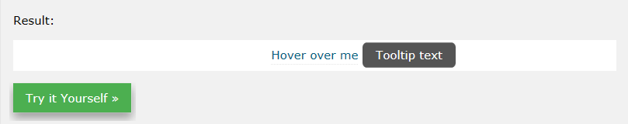

Left Tooltip
.tooltip .tooltiptext {
top: -5px;
right: 105%;
}

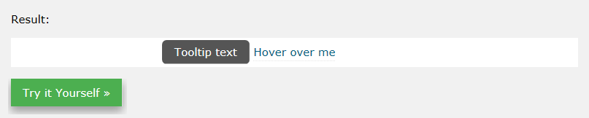
If you want the tooltip to appear on top or on the bottom, see examples below. Note that we use the margin-left property with a value of minus 60 pixels. This is to center the tooltip above/below the hoverable text. It is set to the half of the tooltip's width (120/2 = 60).

Top Tooltip
.tooltip .tooltiptext {
width: 120px;
bottom: 100%;
left: 50%;
margin-left: -60px; /* Use half of the width (120/2 = 60), to center the tooltip */
}
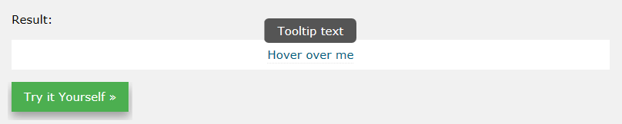

Bottom Tooltip
.tooltip .tooltiptext {
width: 120px;
top: 100%;
left: 50%;
margin-left: -60px; /* Use half of the width (120/2 = 60), to center the tooltip */
}

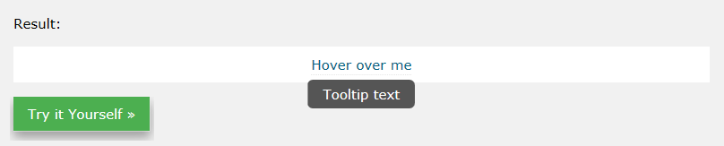Tooltip Arrows
To create an arrow that should appear from a specific side of the tooltip, add "empty" content after tooltip, with the pseudo-element class ::after together with the content property. The arrow itself is created using borders. This will make the tooltip look like a speech bubble.
This example demonstrates how to add an arrow to the bottom of the tooltip:

Bottom Arrow
.tooltip .tooltiptext::after {
content: " ";
position: absolute;
top: 100%; /* At the bottom of the tooltip */
left: 50%;
margin-left: -5px;
border-width: 5px;
border-style: solid;
border-color: black transparent transparent transparent;
}

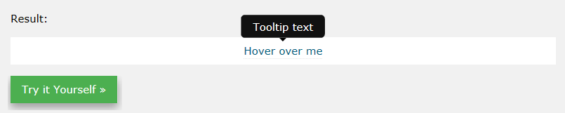Example Explained
Position the arrow inside the tooltip: top: 100% will place the arrow at the bottom of the tooltip. left: 50% will center the arrow.
Note: The border-width property specifies the size of the arrow. If you change this, also change the margin-left value to the same. This will keep the arrow centered.
The border-color is used to transform the content into an arrow. We set the top border to black, and the rest to transparent. If all sides were black, you would end up with a black square box.
This example demonstrates how to add an arrow to the top of the tooltip. Notice that we set the bottom border color this time:

Top Arrow
.tooltip .tooltiptext::after {
content: " ";
position: absolute;
bottom: 100%; /* At the top of the tooltip */
left: 50%;
margin-left: -5px;
border-width: 5px;
border-style: solid;
border-color: transparent transparent black transparent;
}
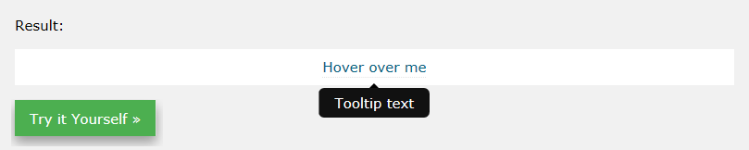
This example demonstrates how to add an arrow to the left of the tooltip:

Left Arrow
.tooltip .tooltiptext::after {
content: " ";
position: absolute;
top: 50%;
right: 100%; /* To the left of the tooltip */
margin-top: -5px;
border-width: 5px;
border-style: solid;
border-color: transparent black transparent transparent;
}
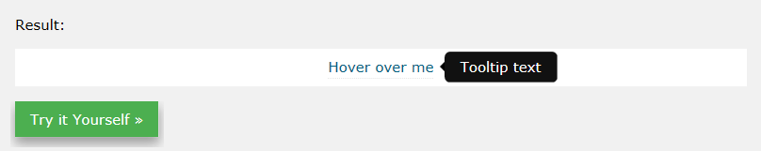

Right Arrow
.tooltip .tooltiptext::after {
content: " ";
position: absolute;
top: 50%;
left: 100%; /* To the right of the tooltip */
margin-top: -5px;
border-width: 5px;
border-style: solid;
border-color: transparent transparent transparent black;
}
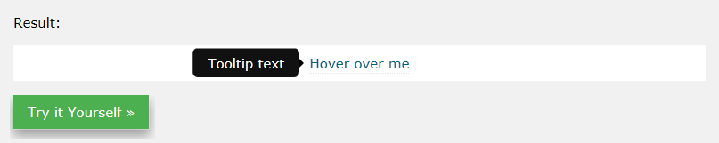

Fade in Tooltips (Animation)
If you want to fade in the tooltip text when it is about to be visible, you can use the CSS transition property together with the opacity property, and go from being completely invisible to 100% visible, in a number of specified seconds (1 second in our example):

Example
.tooltip .tooltiptext {
opacity: 0;
transition: opacity 1s;
}
.tooltip:hover .tooltiptext {
opacity: 1;
}
Note: You will learn more about transitions and animations later in our tutorial.

